|  |
| --- |
| **Your** |
| **Sparkhound Shop** |
| **Manager Manual** |

|  |
| --- |
|  |

Utilizing the tools associated with your management account, you will be able to effectively control your brand, quality and cost.

Table of Contents

Management Roles and Capability Overview 2

Your shop managers (on launch date) 2

Accessing Management Tools 2

Management Dashboard Overview 2

Order Reports 4

Running Detailed Order Reports 4

Exporting Order Reports 5

Customer Management 6

To View All customers 6

Searching Customers 7

View Individual Customer Details 7

Granting Management 8

Customer Role Descriptions 9

Exiting Administration Module 9

Quality Assurance and Customer Service 9

# Management Roles and Capability Overview

**Site Managers:**

* Access to administration area
* Run order reports
* Manage customer roles (i.e. Upgrade customer accounts to Management)
* Review order information
* Customer management

# Your shop managers *(on launch date)*

|  |  |
| --- | --- |
| **Name** | **Title** |
| **Site Manager** | Tommy Mann |

# Accessing Management Tools

Once administrator access is granted, an Administration strip will appear along the top of the page. (Shown below)



Clicking on the strip will bring you to the Administration Module.

# **Management Dashboard Overview**

In the Management Dashboard Area, you will be able to see numerical and graphical representations of your site’s statistics. (Shown below)

* **Order Totals** (By status)
* **Incomplete order** (With Status)
* **Best Sellers** (By quantity or dollar amount)
* **And More**

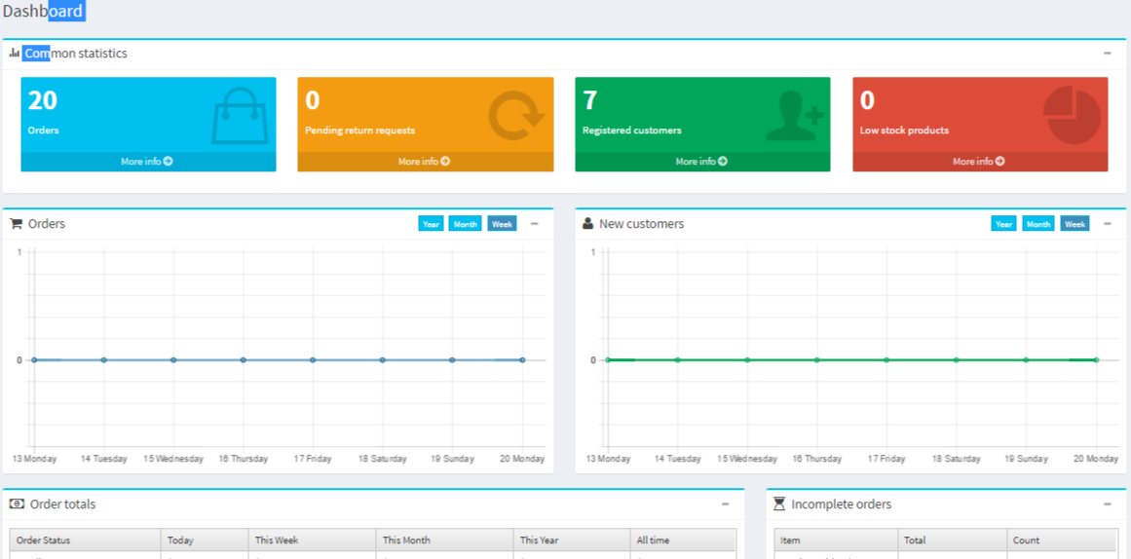

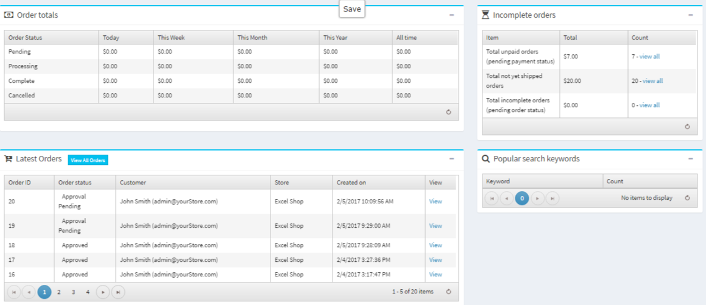

Each “*View”* (pictured above) will bring you to a more detailed description of each specific statistic.

# Order Reports

In the Administration Module, you will find a “*Sales”* tab on the side menu bar. In the drop down, Click on “*Orders*”. (Shown below)



The order report page will appear. This page will allow you to find all orders from your site with all corresponding order information. (Shown below)

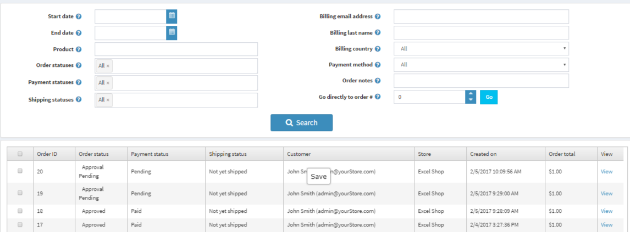

## Running Detailed Order Reports

To add detail to your report, input your desired search parameters in the browser tools.

(Shown below)

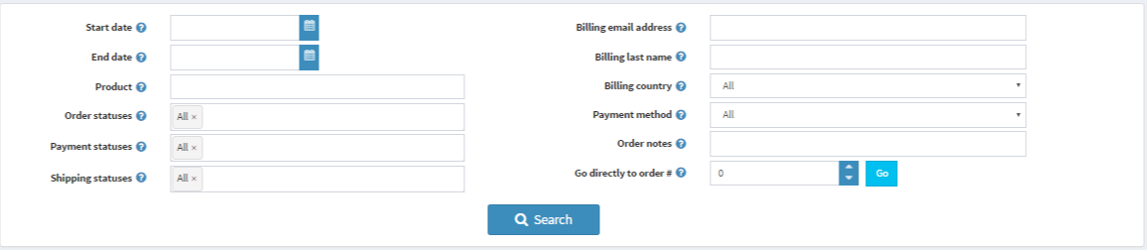

Once your search parameters are set, Press “*Search*” to see your search results.

For Example, under the “Sales” tab click on “Orders” to be redirected to the Orders Overview page

Under the Search filters, you will find the “**Office**” drop down option. In the drop down, select an office for which you would like to run a report. Once selected, press “**Search**” and all orders that were billed to that office will appear. (Shown below)



## Exporting Order Reports

To export and download order information, navigate to the drop-down on the top of the sales information page. (Shown below)

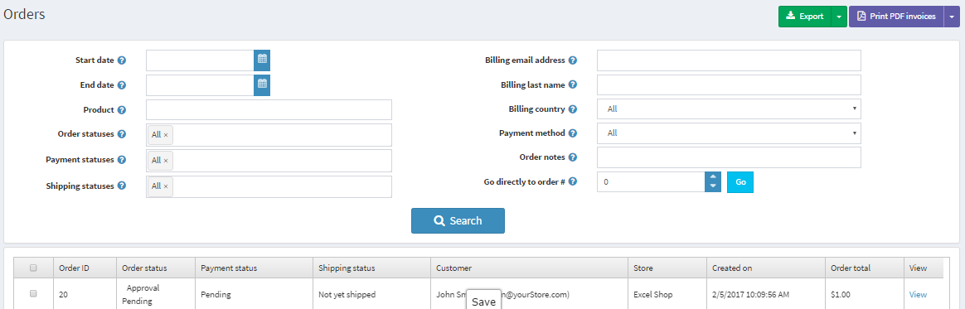

Press the drop down arrow next to “Export”.



Exporting options will appear, select your desired option.

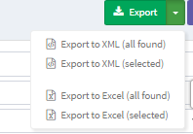

Once you have decided on your option, simply press the corresponding button to begin the download. Once downloaded, visit your downloads folder to find your informational document.

# Customer Management

To view a complete list of all site customers, visit the customer link in the Administration module. Click “Customers” found in the side menu bar. Here, you will be able to run reports on customers and upgrade customer accounts to Site Administrators.



## To View All customers

In the administration module under the “Customer” tab, click on “Customers”. This will bring you to a comprehensive list of site customers.



Once you click “Customers”, you will be redirected to the Customer Overview.

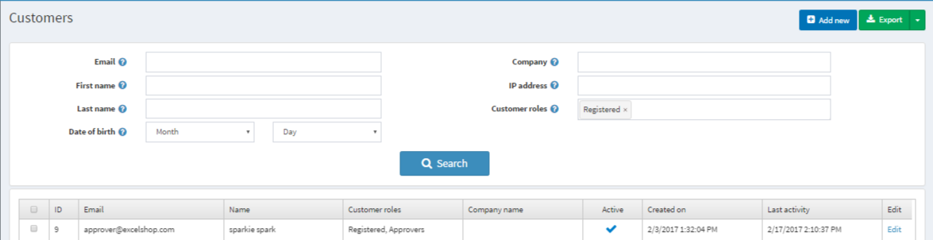

## Searching Customers

To search customers on the site, simply use the browsing filters to find your desired customer(s). Click or enter your search refiners, and press “Search”. (Shown Below)

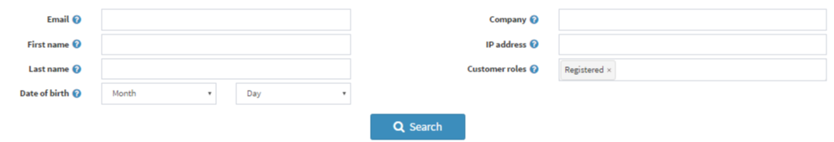

*Your customer overview page will reflect your search results (Shown Below)

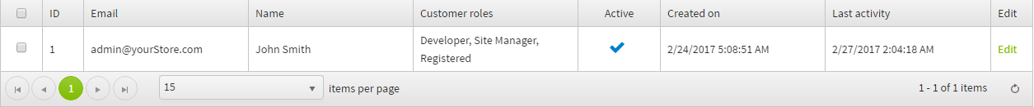

## View Individual Customer Details

First, search and find your desired customer. To view their individual customer details, simply press “Edit” found at end of each customer row. (Shown Below)





Once you click “Edit”, you will be redirected to the individual customer information page. Here, you can view and edit all customer information pertaining to that customer.



## Granting Management

As a Site Administrator, you will be able to grant registered customers Administration access. To grant Administration access, search and visit the individual customer information page.

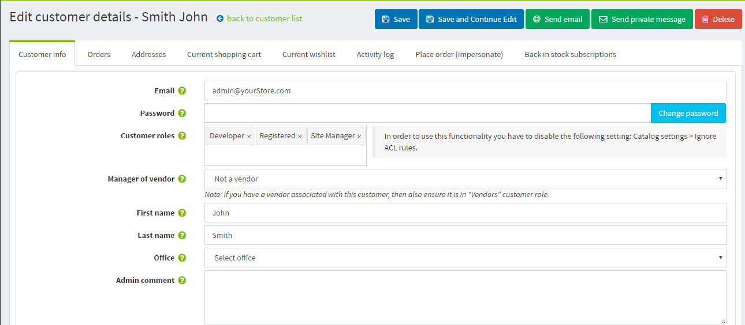

On the customer option toolbar (Pictured Below), find “Customer Roles” section on the “Edit customer details” page.

Select the role(s) you would like to assign to this customer.



Once you have selected desired customer roles, press “Save” found at the top right of the customer details page. (Shown Below)



## Customer Role Descriptions

**Site Manager** - All reporting features and customer role modification.

**Registered**- Regular account holders.

**Vendors-** Should not be granted to any users- for internal use only

**Developer**- Should not be granted to any users - for development use only.

# Exiting Administration Module

To Exit the Administration Module, click “**Public Store**” found on the top right of page.



# Quality Assurance and Customer Service

If you have any questions about your management account or tools, please feel free to contact Z|Apparel’s support team.